# **Teste 1**

* Entrega: Sem prazo
* Pontos: 34
* Perguntas: 17
* Limite de tempo: Nenhum
* Tentativas permitidas: Sem limite

## **Instruções**

Este questionário aborda o conteúdo dos quatro primeiros módulos da Introdução ao Packet Tracer 1.1. Ele foi projetado para fornecer uma oportunidade adicional de praticar as habilidades e conhecimentos apresentados no curso e ajudar a prepará-lo para usar esta ferramenta em seus estudos futuros. Você terá várias tentativas permitidas e a nota não aparecerá no livro de notas. Existem vários tipos de tarefas que podem estar disponíveis neste questionário.

NOTA: Os questionários permitem pontuação parcial de crédito em todos os tipos de itens para promover o aprendizado. Os pontos nos testes também podem ser deduzidos por responder incorretamente.

Pergunta 1

0 / 2 pts

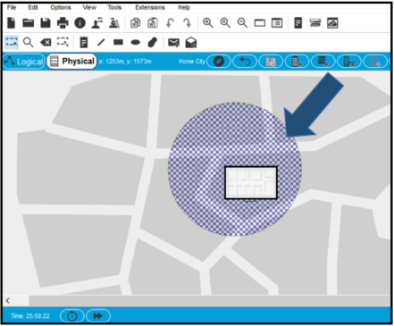

Refer to the exhibit. What does the shaded area represent?

Resposta correta

It defines the wireless signal coverage.

It is just a background image.

Você respondeu

It is used as a temporary location to add devices that will be moved into the building.

It defines an area where you cannot add any new buildings.

Refer to curriculum topic: 4.1.1

Packet Tracer has two views: (1) the logical view which is the default view and used for creating the network and (2) the physical view which allows you to see wiring closets, a room or building layout, or wireless coverage for a specific wireless router.

Pergunta 2

2 / 2 pts

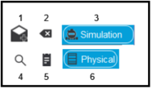

Refer to the exhibit. Match each numbered Packet Tracer menu icon with a description. (Not all options are used.)

Correto!

icon 1

Correto!

icon 2

Correto!

icon 3

Correto!

icon 4

Correto!

icon 5

Correto!

icon 6

Outras opções de respostas incorretas:

* Add a PC to the network.

Refer to curriculum topic: 3.1.1

Pergunta 3

2 / 2 pts

A PC and two laptops need to be added to a wireless router on the Packet Tracer network. What icon would provide the correct components?

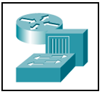





Correto!



Refer to curriculum topic: 2.1.1

Pergunta 4

2 / 2 pts

A technician needs to add a home wireless router. Which icon should the technician select?



i344035v1n2_299213b.PNG

Correto!



i344035v1n2_299213d2.PNG

Refer to curriculum topic: 2.1.1

The network devices icon in the bottom left corner of the Cisco Packet Tracer window allows a router, switch, hub, wireless device, security, or WAN emulation to be added to the logical workspace.

Pergunta 5

2 / 2 pts

Which icon is the default icon for a .pka file?



Correto!





Refer to curriculum topic: 4.2.1

Pergunta 6

2 / 2 pts

i344036v1n3_344036.PNG

Refer to the exhibit. The above icon is in the lower right hand corner of the Packet Tracer screen. What might the person using Packet Tracer be doing?

adding a city view as a background

Correto!

testing connectivity by using simple or complex PDUs

creating a new network

deleting components from an existing network

Refer to curriculum topic: 2.1.1

The two modes available in Packet Tracer are realtime mode and simulation mode. Simulation mode allows for the creation and capture of PDUs on the network.

Pergunta 7

2 / 2 pts

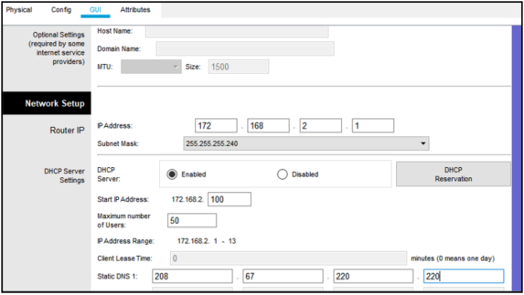

A technician selected the GUI interface on a wireless router and added a DNS address of 208.67.220.220. The technician then immediately exited the GUI interface. What will occur as a result of this configuration?

All connected host devices, configured with DHCP, will automatically be sent the IP address of the DNS server.

Correto!

Because the technician forgot to save the configuration, the DNS server address will not be sent to connected devices.

The technician should have used the **Config** tab to enter the DNS address.

The technician should check the **Physica**l tab to ensure that the wireless router is powered on.

Refer to curriculum topic: 2.1.1

When working with a wireless device within the Packet Tracer GUI environment, scroll to the bottom and select the **Save Settings** option for each menu item.

Pergunta 8

0 / 2 pts

Fill in the blank.

A technician can create PDUs in Packet Tracer to forward HTTP packets to test a web server.

**Responder 1:**

Você respondeu Simple

Resposta correta

complex

Refer to curriculum topic: 3.1.1

Pergunta 9

2 / 2 pts

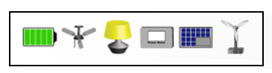

Refer to the exhibit. What description matches the function of the Packet Tracer devices shown?

security devices

Correto!

IoT devices

networking devices

cabling components

Refer to curriculum topic: 2.1.1

Pergunta 10

0 / 2 pts

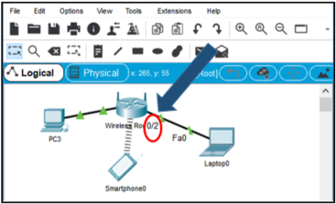

Refer to the exhibit. How do you display the interface number where the cable is attached to a device?

The labels must always be manually entered.

Você respondeu

On the config tab of the device, choose **show interface number**.

Enter the **no shutdown** command in interface configuration mode.

Resposta correta

Hover the mouse cursor over the cable.

Refer to curriculum topic: 2.1.1

When working within Packet Tracer, hover the mouse cursor over the cable close to where it connects to a device to see the specific interface number. Hover over the device to see interface information such as IP address and link status.

Pergunta 11

2 / 2 pts

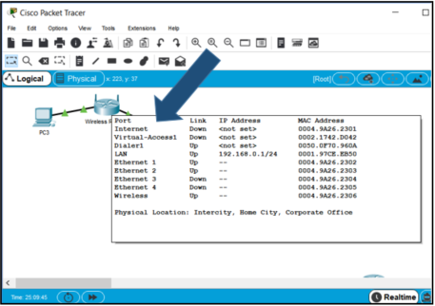

Refer to the exhibit. How do you display the popup window to show the additional device information?

Choose **File > device info popup**

Correto!

Hover the cursor over the device icon.

Right-click the device to select detailed information.

Double-click the device icon.

Refer to curriculum topic: 2.1.1

By hovering over a Packet Tracer device, information such as interface status and IP address displays.

Pergunta 12

2 / 2 pts

Where in Packet Tracer can you create a new building or wiring closet?

virtual workspace

logical workspace

simulation workspace

Correto!

physical workspace

Refer to curriculum topic: 4.1.1

Here is a link to the  [Packet Tracer File](https://373583482.netacad.com/courses/1008829/files/85621650/download?wrap=1).

Use this Packet Tracer Activity to answer the following five items.

Pergunta 13

2 / 2 pts

Add a PC and connect it to the wireless router with a straight-through cable. What icon should be selected to find the required cable?

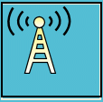



Correto!





Refer to curriculum topic: 2.1.1

Pergunta 14

2 / 2 pts

Send a simple PDU from the new PC to the server.

True or False?

The ping will work on the newly added PC as soon as the link lights turn green.

true

Correto!

false

Refer to curriculum topic: 3.1.1

The wireless router is providing the IP addresses via DHCP. The PC must be configured with DHCP before communications to the server will work.

Pergunta 15

2 / 2 pts

Using the Packet Tracer network, add and associate a laptop as a device on the wireless router. Use HTTP to connect to www.cisco.com. What is the special message?

You made it!

Your wireless configuration works.

Correto!

Way to go!

Awesome!

Packet Tracer is cool!

Refer to curriculum topic: 2.1.1

Pergunta 16

2 / 2 pts

Switch to simulation mode. Select **Laptop0/Desktop/HTTP**, enter a URL of www.cisco.com and click **GO**. What is the value of the Destination Port number on the outbound DNS packet that was created?

1025

800

57

Correto!

53

1

Refer to curriculum topic: 3.1.1

Pergunta 17

2 / 2 pts

Fill in the blank.

The BranchNetwork router has been configured to support wired and wireless users.

**Responder 1:**

Correto! 25

Resposta correta

twenty-five

Resposta correta

twenty five

Refer to curriculum topic: 2.1.1